


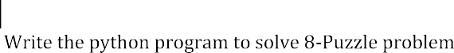
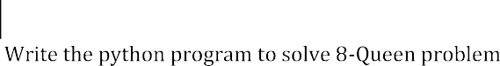
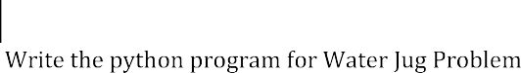
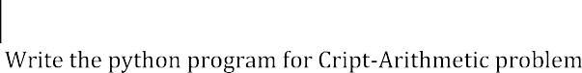
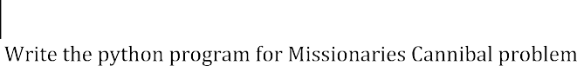
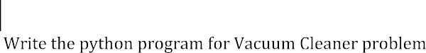
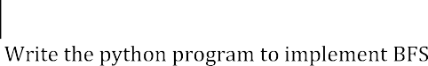
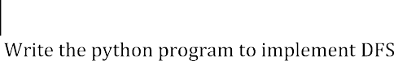
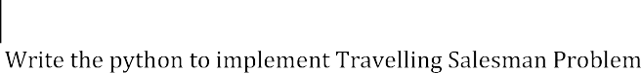
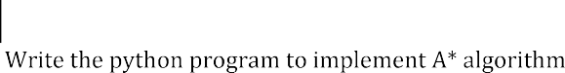
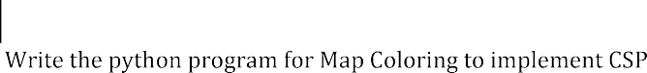
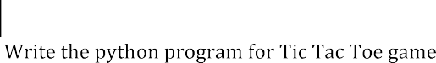
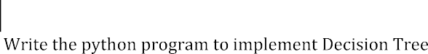
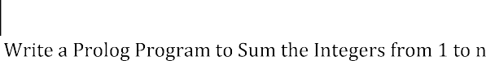
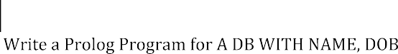
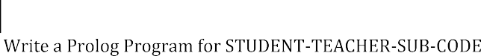
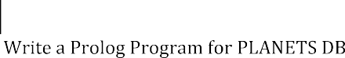
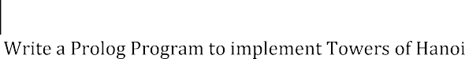
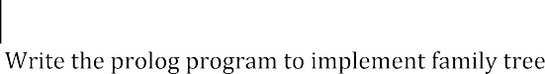
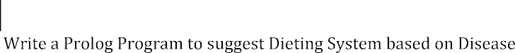
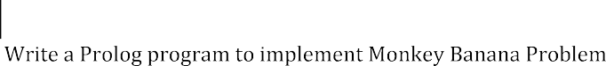
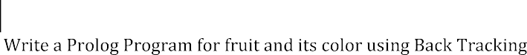
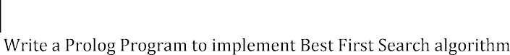
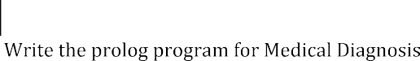
32 | Write a Prolog program to implement pattern matching
33  33 | Write a Prolog program to find the number of vowels

